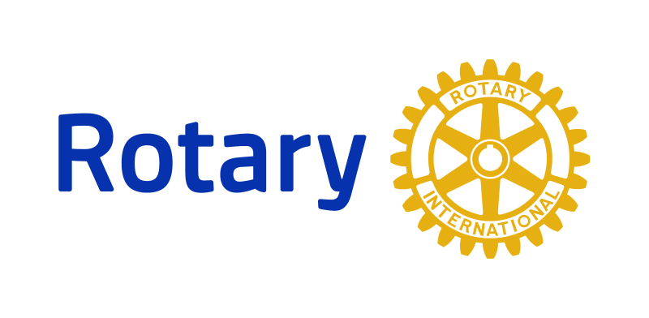**Emerging Leader**

**Program**

The Emerging Leader Program is designed to identify and develop emerging leaders within our Rotary club, with the goal of preparing them for future leadership roles within the club and beyond. This program will provide participants with valuable leadership skills, networking opportunities, and exposure to Rotary's initiatives and values. The Emerging Leader Program is an excellent opportunity for our members to develop their leadership skills and prepare for future leadership roles within the club and beyond. We encourage eligible members to apply and take advantage of this valuable program. Let us continue to build a strong and effective Rotary club that serves our community and beyond.

**Eligibility:**

- Must be a current member of our Rotary club.

- Must have been a member for at least one year.

- Must have demonstrated a commitment to Rotary's values and initiatives.

- Must have a strong interest in developing leadership skills.

**Program Components:**

1. Leadership Workshops: Participants will attend a series of workshops focused on developing leadership skills. These workshops will cover topics such as communication, team building, conflict resolution, and project management.

2. Mentorship Program: Participants will be paired with a mentor who will provide guidance and support throughout the program. Mentors will be experienced Rotarians who have held leadership positions within the club.

3. Networking Opportunities: Participants will have the opportunity to attend networking events and meet with Rotarians from other clubs. These events will provide valuable networking opportunities and exposure to Rotary's initiatives and values.

4. Community Service Projects: Participants will be involved in community service projects organized by our club. These projects will provide hands-on experience in leadership and project management.

5. International Service Trip: Participants will have the opportunity to participate in an international service trip organized by Rotary. This trip will provide exposure to Rotary's international initiatives and the opportunity to develop global leadership skills.

**Program Duration and Requirements:**

- The program will run for one year, with the option to extend for an additional year.

- Participants must attend at least 80% of the workshops and events.

- Participants must complete at least one community service project and participate in the international service trip.

**Program Benefits:**

- Develop valuable leadership skills.

- Build relationships with experienced Rotarians.

- Gain exposure to Rotary's initiatives and values.

- Develop a global perspective on leadership and service.

- Prepare for future leadership roles within the club and beyond.